Riphah International University Lahore, Pakistan

Riphah School of Computing & Innovation

Final Year Project
PROJECT REPORT (Part-1)

[Skill Exchange Platform]

Project ID: [write ID here Issued by FYP Manager]

Project Team
Student Name | Student ID | Program | Contact Number | Email Address
Hira Zaman | 48153 | BSSE
Mahnoor Qureshi | 48038 | BSSE

[Project Supervisor]
Professor Dr Waqar Mehmood
Project Report
[Skill Exchange Platform]

Change Record
Author(s) | Version | Date | Notes | Supervisor’s Signature
 | 1.0 |  | <Original Draft>
 |  |  | <Changes Based on Feedback from Supervisor>
 |  |  | <Changes Based on Feedback From Faculty>
 |  |  | <Added Project Plan>
 |  |  | <Changes Based on Feedback from Supervisor>

APPROVAL
Project Supervisor
Comments: ___________________________________________________________________
_____________________________________________________________________________
Name:______________________________
Date:_______________________________ | Signature:__________________________

Project Manager
Comments: ___________________________________________________________________
_____________________________________________________________________________
Date:_______________________________ | Signature:__________________________

Head of the Department
Comments: ___________________________________________________________________
_____________________________________________________________________________
Date:_______________________________ | Signature:__________________________

Dedication
We dedicate this project to our parents, teachers, and mentors whose continuous support, encouragement, and guidance helped us throughout our academic journey. Their motivation inspired us to complete this project successfully.
We also dedicate this work to all learners and skilled individuals who believe in sharing knowledge and helping others grow. This project reflects our effort to create a platform that promotes collaboration, learning, and equal opportunities for everyone.
Finally, we thank our teammates and friends for their cooperation, hard work, and valuable contributions during the development of this project.

Acknowledgements

We would like to express our sincere gratitude to Almighty Allah for giving us the strength, knowledge, and patience to complete this project successfully.
We are deeply thankful to our respected supervisor and teachers for their valuable guidance, continuous support, and constructive feedback throughout the development of this project. Their encouragement and expert advice played an important role in improving our work.
We also appreciate the support and cooperation of our teammates, friends, and classmates who contributed their ideas and assistance during different phases of the project.
Finally, we are especially grateful to our parents and families for their constant motivation, prayers, and support throughout our academic journey.

Executive Summary
The Skill Exchange Platform is an AI-powered system designed to connect people who want to learn new skills with those willing to teach. Unlike traditional paid courses, this platform enables users to exchange knowledge directly, making learning more affordable, accessible, and flexible
Users can create profiles, list skills they can teach or want to learn, communicate through chat, schedule online sessions, and provide feedback after each session.
The admin dashboard is AI-powered: it automatically verifies skills, detects fake users, categorizes complaints, monitors sessions for suspicious activity, and provides real-time analytic to the admin. Admin intervenes only when necessary.
The system’s key benefits include accessible skill development, reliable verification of expertise, and a structured, collaborative learning environment. It aims to build a trusted community where learning is shared, efficient, and widely available to everyone
The platform will also provide a customized AI-based learning path where course content is adjusted according to the learner’s educational background and skill level, making learning easier and more effective.
A hybrid revenue model will be implemented where basic features remain free, while premium features such as expert teachers, structured courses, and guided learning paths will be offered at an affordable cost to ensure sustainability of the system.

Table of Contents
Dedication iv
Acknowledgements v
Executive Summary vi
Table of Contents vii
List of Figures ix
List of Tables x
Chapter 1 1
Introduction 1
1.1. Background 2
1.2. Motivations and Challenges 2
1.3. Goals and Objectives 2
1.4. Literature Review/Existing Solutions 2
1.5. Gap Analysis 2
1.6. Proposed Solution 2
1.7. Project Plan 3
1.7.1. Work Breakdown Structure 3
1.7.2. Roles & Responsibility Matrix 3
1.7.3. Gantt Chart 3
1.8. Report Outline 3
Chapter 2 4
Software Requirement Specifications 4
2.1. Introduction 5
2.1.1. Purpose 5
2.1.2. Document Conventions 5
2.1.3. Intended Audience and Reading Suggestions 5
2.1.4. Product Scope 5
2.1.5. References 6
2.2. Overall Description 6
2.2.1. Product Perspective 6
2.2.2. Product Functions 6
2.2.3. User Classes and Characteristics 6
2.2.4. Operating Environment 7
2.2.5. Design and Implementation Constraints 7
2.2.6. User Documentation 7
2.2.7. Assumptions and Dependencies 7
2.3. External Interface Requirements 8
2.3.1. User Interfaces 8
2.3.2. Hardware Interfaces 8
2.3.3. Software Interfaces 8
2.3.4. Communications Interfaces 9
2.4. System Features 9
2.4.1. System Feature 1 9
2.4.1.1. Description and Priority 9
2.4.1.2. Stimulus/Response Sequences 9
2.4.1.3. Functional Requirements 9
2.4.2. System Feature 2 10
2.4.2.1. Description and Priority 10
2.4.2.2. Stimulus/Response Sequences 10
2.4.2.3. Functional Requirements 10
2.4.3. System Feature 3 (and so on) 11
2.5. Other Nonfunctional Requirements 11
2.5.1. Performance Requirements 11
2.5.2. Safety Requirements 11
2.5.3. Security Requirements 12
2.5.4. Software Quality Attributes 12
2.5.5. Business Rules 12
2.6. Other Requirements 12
Chapter 3 13
Use Case Analysis 13
3.1. Use Case Model 14
3.2. Fully Dressed Use Cases 14
Chapter 4 15
System Design 15
4.1. Architecture Diagram 16
4.2. Domain Model 16
4.3. Entity Relationship Diagram with data dictionary 16
4.4. Class Diagram 17
4.5. Sequence / Collaboration Diagram 17
4.6. Operation contracts 17
4.7. Activity Diagram 18
4.8. State Transition Diagram 18
4.9. Component Diagram 18
4.10. Deployment Diagram 19
4.11. Data Flow diagram [only if structured approach is used - Level 0 and 1] 19
Chapter 5 20
Implementation 20
5.1. Important Flow Control/Pseudo codes 21
5.2. Components, Libraries, Web Services and stubs 21
5.3. Deployment Environment 21
5.4. Tools and Techniques 22
5.5. Best Practices / Coding Standards 22
5.6. Version Control 22
Appendices 23
Appendix A: Information / Promotional Material 24
Reference and Bibliography 27
Index 29

List of Figures

1.1 Caption of first figure of first chapter 6
1.2 Caption of second figure of first chapter 7
2.1 Caption of first figure of second chapter 14
2.2 Caption of second figure of second chapter 22
2.3 Caption of third figure of second chapter 26
5.1 Caption of first figure of fifth chapter 49
5.2 Caption of second figure of fifth chapter 49

List of Tables

1.1 label of first table of first chapter 6
1.2 label of second table of first chapter 7
2.1 label of first table of second chapter 14
2.2 label of second table of second chapter 22
2.3 label of third table of second chapter 26
5.1 label of first table of fifth chapter 49
5.2 label of second table of fifth chapter 49

Chapter 1

Introduction

Chapter 1: Introduction
Many people want to learn new skills, but learning platforms usually require money or formal courses. At the same time, many people already have useful skills and are willing to teach others. However, there is no simple system where people can easily connect and exchange skills with each other. The Skill Exchange Platform is a digital system where users can teach a skill they know and learn a skill they want from others. The system will automatically match people with similar interests and help them communicate and schedule learning sessions. Artificial Intelligence will be used to verify user skills and the admin dashboard now uses AI to automate monitoring, verification, and reporting tasks. This will make learning easier, faster, and more reliable.

Background
Online learning platforms have become an important part of modern education and skill development. Many people use digital platforms to learn new skills, improve their careers, and gain knowledge from experts around the world. However, most existing platforms mainly focus on paid courses and one-way learning systems, where learners only consume content instead of interacting directly with skilled individuals.

At the same time, many people possess valuable practical skills and knowledge but do not have a suitable platform to share or exchange them with others. This creates a gap between people who want to learn and those who are willing to teach. Existing social media platforms allow communication, but they do not provide a structured environment for skill exchange, verification, scheduling, and learning management.

The Skill Exchange Platform is proposed to solve this problem by providing a peer-to-peer learning environment where users can both teach and learn skills. The platform uses Artificial Intelligence (AI) to improve user matching, skill verification, monitoring, and personalized learning recommendations. It enables users to connect based on shared interests and learning goals while maintaining trust, quality, and security through AI-powered administration features.

The system aims to make learning more accessible, collaborative, affordable, and interactive compared to traditional online learning systems.

Motivations and Challenges
Motivations:
The rapid growth of digital learning has increased the demand for accessible and flexible education systems. Many individuals want to learn new skills but cannot afford expensive online courses or formal training programs. At the same time, many skilled people are willing to share their knowledge and help others learn. This creates an opportunity for a collaborative learning platform where users can exchange skills directly.
The main motivations behind developing the Skill Exchange Platform are
- To make learning affordable and accessible for everyone
- To encourage peer-to-peer knowledge sharing
- To connect learners and skilled individuals through a single platform
- To create an interactive and collaborative learning environment
- To use Artificial Intelligence (AI) for better matching, verification, and monitoring
- To provide flexible learning opportunities based on user interests and availability
- To promote continuous skill development and community learning
Challenges:
Although the platform offers many benefits, several challenges must be addressed to ensure effective system performance and user trust.
The major challenges include
- Verifying the authenticity of user skills and qualifications
- Preventing fake accounts and fraudulent activities
- Ensuring accurate AI-based matching between learners and teachers
- Maintaining trust and quality within the learning community
- Managing real-time communication and session scheduling efficiently
- Handling large amounts of user data securely
- Providing smooth performance for multiple users simultaneously
- Protecting user privacy and maintaining data security
- Integrating AI modules and third-party services effectively

Goals and Objectives
The main goal of the Skill Exchange Platform is to develop an AI-powered learning environment where users can teach and learn skills through peer-to-peer interaction. The system aims to make learning more accessible, collaborative, affordable, and efficient by connecting individuals based on their skills and interests.

The objectives of the proposed system are
- To develop a digital platform for skill exchange between users
- To enable users to create profiles and manage teaching and learning skills
- To implement AI-based matching between learners and teachers
- To provide skill verification through quizzes and document validation
- To support real-time chat and communication between users
- To provide session scheduling and online meeting features
- To build an AI-powered admin system for monitoring and control
- To maintain trust and quality through ratings and feedback mechanisms
- To ensure system security, reliability, and user privacy
- To support both free learning and premium expert-based courses
- To create a user-friendly and scalable platform for future expansion
- To encourage collaborative learning and knowledge sharing within the community

Literature Review/Existing Solutions
Many online learning platforms already exist, such as Udemy, Coursera, and Skillshare, which provide structured courses for skill development. These platforms mainly focus on paid learning and recorded course content.

Social platforms like YouTube and Facebook allow users to share educational content and communicate with others, but they do not provide a dedicated system for organized skill exchange or verification.

Freelancing platforms such as Fiverr and Upwork connect skilled individuals with clients for paid work, but they are not designed for collaborative peer-to-peer learning.

Most existing systems lack AI-based matching, proper skill verification, and structured interaction between learners and teachers. The proposed Skill Exchange Platform aims to overcome these limitations by combining peer-to-peer learning, AI-powered matching, skill verification, communication, and session management in a single platform.

Existing Solutions Comparison

Feature / Platform | Udemy / Coursera / Skillshare | Reddit / Facebook Groups | Skill Exchange Platform (Proposed)
Learning Model | Structured courses | Informal discussions | Peer-to-peer skill exchange
Cost | Mostly paid | Free | Free with optional premium features
Direct Interaction | Limited | Unstructured | Direct learner-teacher interaction
Skill Verification | Course completion only | None | AI-based verification and quizzes
Matching System | Manual search | None | AI-powered matching
Session Scheduling | Limited | None | Flexible scheduling
Communication | Discussion forums | Messaging/comments | Real-time chat and meetings
Progress Tracking | Course tracking | None | Session history and feedback
Trust & Quality Control | Moderate | Low | AI-powered monitoring and ratings
Community Collaboration | Limited | Informal | Structured learning community

Gap Analysis
Although many online learning and communication platforms are available today, several limitations still exist in current systems. Most existing platforms mainly focus on paid courses, freelancing services, or unstructured community discussions rather than collaborative peer-to-peer skill exchange.

Current learning platforms such as Udemy and Coursera provide high-quality educational content, but they mainly support one-way learning where users consume pre-recorded courses instead of directly exchanging skills with other learners. These systems also offer limited personalization and interaction between users.

Social platforms like Facebook groups and Reddit communities allow users to communicate and share knowledge informally, but they lack structured learning management, skill verification, scheduling mechanisms, and quality assurance features.

Similarly, freelancing platforms such as Fiverr and Upwork are primarily designed for commercial services and job-based interactions rather than educational collaboration and mutual learning.

The major gaps identified in existing systems are:

- Lack of a dedicated peer-to-peer skill exchange environment
- Limited direct interaction between learners and teachers
- Absence of reliable skill verification mechanisms
- No integrated AI-based matching for personalized learning connections
- Weak trust and quality control systems
- Limited support for collaborative and community-driven learning
- Lack of integrated scheduling, communication, and feedback features in a single platform
- Minimal use of AI for monitoring, fraud detection, and personalized recommendations
- High dependency on paid learning models, reducing accessibility for many users

The proposed Skill Exchange Platform aims to address these gaps by providing a unified AI-powered system that supports skill exchange, user verification, intelligent matching, real-time communication, scheduling, monitoring, and collaborative learning within a single platform.

Proposed Solution
The proposed system is an AI-powered Skill Exchange Platform designed to connect people who want to learn new skills with individuals who are willing to teach them. The platform provides a collaborative peer-to-peer learning environment where users can both teach and learn based on their interests, experience, and skill levels.

The system allows users to create profiles, add skills they can teach or want to learn, and connect with suitable learning partners through an AI-based matching mechanism. Artificial Intelligence is used to analyze user profiles, interests, learning preferences, and activity patterns in order to provide accurate and personalized recommendations.

To maintain trust and quality, the platform includes a skill verification system where users must verify their teaching abilities through quizzes or document submission before offering sessions. An AI-powered admin module further improves system reliability by monitoring suspicious activities, detecting fake users, handling complaints, and generating system analytics.

The platform also provides real-time communication and collaboration features such as chat, notifications, session scheduling, and online meeting integration through services like Google Meet. Users can schedule sessions according to mutual availability and conduct live learning sessions online.

In addition to free peer-to-peer learning, the platform offers premium features including expert-led sessions, structured courses, and personalized learning paths. A feedback and rating system is included to improve transparency, trust, and continuous quality enhancement within the learning community.

The proposed solution aims to provide an accessible, secure, intelligent, and scalable learning ecosystem that encourages knowledge sharing, collaboration, and continuous skill development for users worldwide.

Project Plan
The development of the Skill Exchange Platform will follow a structured and phased project plan to ensure systematic progress, timely completion, and quality assurance. The plan is divided into key phases from requirement gathering to deployment and maintenance.
Phase 1: Requirement Gathering and Analysis
In this initial phase, system requirements will be collected through research and analysis of existing learning platforms. Functional and non-functional requirements will be identified, including user roles, AI-based features, skill verification, communication tools, and security needs.
Phase 2: System Design
This phase focuses on designing the overall architecture of the system. It includes database design, user interface design, and UML diagrams such as use case, class, and sequence diagrams. The integration of AI modules for matching, verification, and monitoring will also be planned.
Phase 3: Implementation
The platform will be developed using suitable programming languages and frameworks. Core modules such as user management, skill exchange, AI matching system, chat system, scheduling, and admin dashboard will be implemented step by step.
Phase 4: AI Integration
Artificial Intelligence components will be integrated into the system. This includes skill verification (quizzes/document validation), recommendation system for matching users, and AI-based admin monitoring for detecting fraud and generating reports.
Phase 5: Testing and Evaluation
The system will be tested to ensure functionality, performance, security, and usability. Different testing methods such as unit testing, integration testing, and user acceptance testing (UAT) will be applied to identify and fix errors.
Phase 6: Deployment
After successful testing, the platform will be deployed on a cloud or web server. The system will be made accessible to users, and real-world usage will be monitored for performance and stability.
Phase 7: Maintenance and Updates
Continuous maintenance will be performed to fix bugs, improve performance, and add new features. User feedback will be used to enhance system functionality and ensure long-term scalability.

Work Breakdown Structure
The Work Breakdown Structure (WBS) divides the Skill Exchange Platform project into smaller, manageable components to ensure organized development, better planning, and efficient execution. Each level represents a breakdown of major deliverables into specific tasks.

Level 1: Project Title
Skill Exchange Platform (AI-Powered Learning System)

Level 2: Major Project Modules
- Project Planning & Requirement Analysis
- System Design
- Frontend Development
- Backend Development
- AI Integration
- Database Design & Management
- Testing & Quality Assurance
- Deployment & Maintenance

Level 3: Detailed Task Breakdown
1. Project Planning & Requirement Analysis
- Identify user requirements
- Define system scope and objectives
- Analyze existing systems
- Prepare documentation
2. System Design
- Design system architecture
- Create UML diagrams (Use Case, Class, Sequence)
- Design UI/UX wireframes
- Design database schema
3. Frontend Development
- Develop user interface (UI)
- Create user registration and login screens
- Build user dashboard
- Implement chat and scheduling interface
4. Backend Development
- Develop APIs and server logic
- Implement authentication system
- Handle user profiles and skill data
- Manage session scheduling logic
5. AI Integration
- AI-based skill matching system
- Skill verification (quiz/document validation)
- AI admin monitoring system
- Recommendation engine
6. Database Design & Management
- Create relational database structure
- Define tables (Users, Skills, Sessions, Feedback)
- Implement data storage and retrieval
- Ensure data security and backup
7. Testing & Quality Assurance
- Unit testing of modules
- Integration testing
- Performance testing
- User Acceptance Testing (UAT)
8. Deployment & Maintenance
- Deploy system on server/cloud
- Monitor system performance
- Fix bugs and issues
- Release updates and new features
The Work Breakdown Structure (WBS) of the Skill Exchange Platform is also presented in table format for better clarity and structured understanding.
Level 1 | Level 2 (Modules) | Level 3 (Tasks)
Skill Exchange Platform (AI-Powered System) | Project Planning & Requirement Analysis | Identify user requirements, define scope, analyze existing systems, prepare documentation
Skill Exchange Platform (AI-Powered System) | System Design | System architecture design, UML diagrams, UI/UX wireframes, database schema design
Skill Exchange Platform (AI-Powered System) | Frontend Development | UI development, login/registration pages, user dashboard, chat & scheduling interface
Skill Exchange Platform (AI-Powered System) | Backend Development | API development, authentication system, profile management, session handling logic
Skill Exchange Platform (AI-Powered System) | AI Integration | Skill matching system, skill verification (quiz/document), AI admin monitoring, recommendation engine
Skill Exchange Platform (AI-Powered System) | Database Design & Management | Database creation, table design (users, skills, sessions, feedback), data security, backup management
Skill Exchange Platform (AI-Powered System) | Testing & Quality Assurance | Unit testing, integration testing, performance testing, user acceptance testing (UAT)
Skill Exchange Platform (AI-Powered System) | Deployment & Maintenance | Server deployment, monitoring, bug fixing, system updates and improvements

Roles & Responsibility Matrix
The Roles & Responsibility Matrix defines the responsibilities of each team member involved in the development of the Skill Exchange Platform. It helps ensure proper task distribution, accountability, and effective project management throughout the software development lifecycle.

Role | Responsibilities
Project Manager | Manage project planning, monitor progress, allocate tasks, manage timeline, and ensure successful project completion
System Analyst | Gather requirements, analyze system needs, prepare documentation, and define system specifications
UI/UX Designer | Design user interface layouts, create wireframes, improve user experience, and maintain responsive design
Frontend Developer | Develop client-side interface, implement dashboards, forms, chat screens, and integrate frontend components
Backend Developer | Develop server-side logic, APIs, authentication system, database connectivity, and session management
AI/ML Developer | Implement AI-based matching, skill verification, recommendation system, and AI-powered monitoring features
Database Administrator (DBA) | Design and manage database structure, ensure data security, backup, recovery, and performance optimization
Tester / QA Engineer | Perform unit testing, integration testing, bug reporting, security testing, and user acceptance testing
System Administrator | Manage server deployment, hosting environment, system monitoring, maintenance, and updates
Users (Learners & Teachers) | Create profiles, exchange skills, participate in sessions, provide feedback, and maintain community interaction
Admin | Monitor platform activities, verify users, handle complaints, manage reports, and maintain platform quality

Gantt Chart
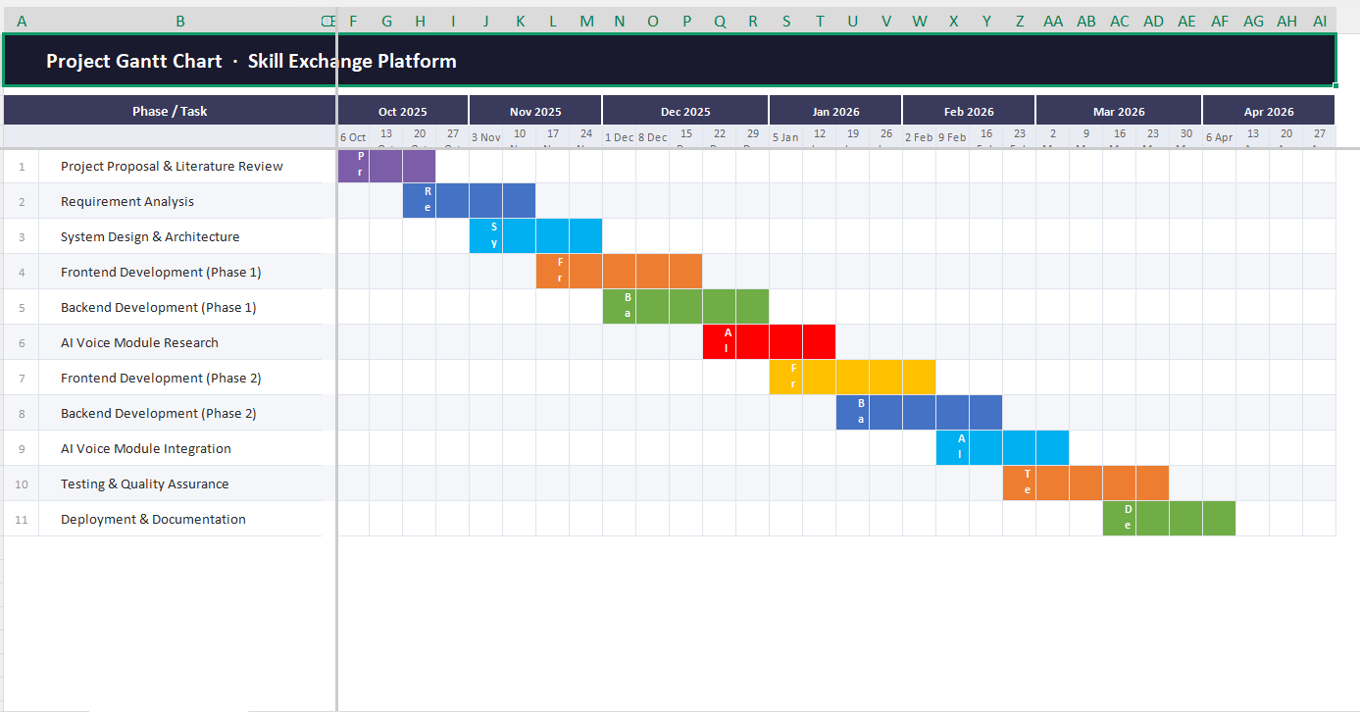

Report Outline
Chapter 1 – Introduction
Presents the project background, motivations, objectives, literature review, problem statement, proposed solution, scope, and project plan.
Chapter 2 – Requirement Analysis
Describes functional and non-functional requirements, user requirements, system requirements, and feasibility analysis of the proposed system.
Chapter 3 – System Design
Explains the overall system architecture, database design, UML diagrams, user interface design, and workflow of the platform.
Chapter 4 – Implementation
Discusses the technologies, tools, frameworks, APIs, and development techniques used to build the system.
Chapter 5 – Testing and Evaluation
Covers unit testing, integration testing, performance evaluation, bug fixing, and system validation results.
Chapter 6 – Deployment and Maintenance
Describes cloud deployment, hosting configuration, system maintenance, and security management.
Chapter 7 – Conclusion and Future Enhancements
Summarizes project achievements, limitations, and future improvements such as advanced AI features and expanded learning services.
References
Contains books , research papers, websites, documentation, and other resources used during the project development

Chapter 2

Software Requirement Specifications

Chapter 2: Software Requirement Specifications

Introduction

Purpose
The purpose of this Software Requirements Specification (SRS) document is to define the requirements and specifications of the Skill Exchange Platform This document provides a detailed description of the system’s functionalities, system behavior, user interactions, constraints, and performance expectations.
The scope of this SRS covers the complete Skill Exchange Platform, including both user-side and admin-side functionalities. The system supports peer-to-peer skill exchange, AI-based learner-teacher matching, skill verification, communication tools, session scheduling, feedback management, and AI-powered administration features.
The document is intended for project stakeholders, developers, system analysts, testers, designers, and future maintainers to ensure a clear understanding of the proposed system and its objectives. It also serves as a reference for system design, implementation, testing, deployment, and future enhancements.

Document Conventions
The following conventions and standards are used throughout this Software Requirements Specification (SRS) document to maintain consistency, readability, and proper understanding of the system requirements.
Headings and subheadings are used to organize different sections of the document systematically.
- Bold text is used to highlight important terms, module names, and key concepts.
- Bullet points and numbered lists are used to present requirements and features clearly.
- The term “System” refers to the proposed Skill Exchange Platform.
- The term “User” refers to learners, teachers, or any registered individual using the platform.
- The term “Admin” refers to the administrator responsible for monitoring and managing the platform.
- “AI” stands for Artificial Intelligence and represents intelligent features such as matching, verification, recommendations, and monitoring.
- Functional requirements describe the features and services provided by the system.
- Non-functional requirements describe system quality attributes such as security, performance, reliability, and usability.
- UML diagrams, tables, and models are used where necessary to represent system structure and behavior visually.
- All requirements are written in simple and clear language to avoid ambiguity and ensure better communication among stakeholders.

Intended Audience and Reading Suggestions
This Software Requirements Specification (SRS) document is intended for all stakeholders involved in the development, management, testing, and use of the Skill Exchange Platform. The document provides detailed information about the system requirements, functionalities, and overall structure to ensure a clear understanding among all parties.
Intended Audience
The primary audience of this document includes
Project Managers – to understand project scope, planning, and system objectives.
System Analysts – to analyze requirements and system behavior.
Software Developers – to implement system functionalities based on defined requirements.
UI/UX Designers – to design user-friendly interfaces and improve user experience.
AI/ML Developers – to develop AI-based matching, verification, and recommendation modules.
Database Administrators – to design and manage the database structure.
Testers / QA Engineers – to perform testing and validate system requirements.
System Administrators – to deploy, monitor, and maintain the platform.
End Users (Learners & Teachers) – to understand the overall purpose and features of the system.
Future Researchers and Maintainers – to support future improvements and system enhancements.
Reading Suggestions
Readers can follow the document according to their roles and interests
- Managers and stakeholders should focus on the introduction, project scope, objectives, and overall system features.
- Developers should carefully study the functional requirements, system architecture, database design, and AI modules.
- Testers should review the functional and non-functional requirements to prepare test cases.
- Designers should focus on user requirements, interface design, and usability-related sections.
- Administrators and maintainers should review deployment, security, monitoring, and maintenance requirements.
This structured approach helps different stakeholders easily access the information most relevant to their responsibilities.

Product Scope
The Skill Exchange Platform is an AI-powered peer-to-peer learning system designed to connect individuals who want to learn new skills with users who are willing to teach their expertise. The platform provides an interactive and collaborative environment where users can exchange knowledge, schedule learning sessions, communicate in real time, and track learning progress.
The main scope of the system includes user registration and profile management, skill listing, AI-based learner-teacher matching, skill verification, session scheduling, communication tools, and feedback management. The platform also includes an AI-powered admin dashboard for monitoring activities, detecting suspicious behavior, managing reports, and maintaining system quality.
The system supports both free peer-to-peer learning and premium expert-led learning services. Users can create profiles, add skills they can teach or want to learn, connect with suitable learning partners, and participate in online sessions through integrated meeting platforms such as Google Meet.
The platform aims to provide:
- Accessible and affordable learning opportunities
- Direct interaction between learners and teachers
- AI-powered personalized recommendations and matching
- Secure and reliable communication and scheduling
- Trust and quality assurance through verification and feedback systems
- A collaborative learning community for continuous skill development
The proposed system is web-based and scalable, allowing future integration of additional features such as mobile applications, advanced analytics, multilingual support, and enhanced AI capabilities.

References
Reference Type | Description
Online Learning Platforms | Udemy, Coursera, Skillshare
Social Platforms | Facebook, Reddit, YouTube
Freelancing Platforms | Fiverr, Upwork
Standards | IEEE SRS documentation standards
AI Technologies | AI-based matching, verification, and recommendation systems
Communication Tools | Google Meet integration concepts
Research Sources | Research papers and articles on e-learning and collaborative learning systems

Overall Description

Product Perspective
The Skill Exchange Platform is a web-based AI-powered learning and collaboration system designed to support peer-to-peer skill exchange between users. The system acts as an independent platform where users can both teach and learn skills through direct interaction, communication, and scheduled learning sessions.
The platform combines features of online learning systems, social interaction platforms, and AI-based recommendation systems into a single integrated environment. It allows users to create profiles, add skills, search for learning partners, communicate in real time, and participate in online learning sessions.
- Artificial Intelligence plays an important role in the system by supporting:
- AI-based learner and teacher matching
- Skill verification through quizzes and document validation
- Personalized learning recommendations
- Fraud detection and admin monitoring
The system also integrates third-party services such as:
- Google Meet for online meetings
- Email and notification services for communication alerts

Product Functions
The Skill Exchange Platform provides various functions to support peer-to-peer learning, communication, skill verification, and system management. The major functions of the system are:
- User registration and login
- User profile creation and management
- Add, update, and manage teaching and learning skills
- AI-based learner and teacher matching
- Skill verification through quizzes and document validation
- Real-time chat and communication system
- Session scheduling and meeting management
- Online meeting integration using Google Meet
- Personalized learning recommendations
- Ratings and feedback system
- Notifications and alerts
- AI-powered admin monitoring and reporting
- Complaint handling and fraud detection
- Progress tracking and session history
- Premium expert-led courses and learning features
- Secure data management and privacy protection

User Classes and Characteristics
The Skill Exchange Platform includes different types of users, each with specific roles, permissions, and system interactions.
User Class | Characteristics
Learners | Users who want to learn new skills. They can search for teachers, join sessions, communicate with others, and provide feedback.
Teachers / Skill Providers | Users who teach skills to others. They can create skill listings, schedule sessions, verify skills, and interact with learners.
Premium Experts | Verified professionals who provide advanced or paid learning sessions and structured courses.
Admin | Responsible for managing the platform, monitoring activities, handling complaints, verifying users, and maintaining system quality through AI-powered tools.
Guest Users | Unregistered users who can browse limited platform information before creating an account.
System Administrator | Manages server deployment, database maintenance, security, backups, and overall system performance.

General Characteristics of Users
- Basic knowledge of web or mobile applications
- Internet access for using online services
- Ability to communicate and interact digitally
- Different skill levels, interests, and learning preferences
- Users may act as both learners and teachers simultaneously within the platform

Operating Environment
The Skill Exchange Platform will operate in a modern web-based and cloud-supported environment to ensure accessibility, scalability, and reliable performance.

Hardware Requirements
- Desktop, laptop, tablet, or smartphone devices
- Minimum 4 GB RAM (recommended 8 GB or higher for smooth performance)
- Stable internet connection for real-time communication and online sessions
Software Requirements
- Web browsers such as Google Chrome, Mozilla Firefox, Microsoft Edge, or Safari
- Operating systems including Windows, Linux, macOS, Android, and iOS (for browser access)
- Server-side environment supporting backend frameworks (e.g., Node.js, Python, or similar technologies)
- Database management system such as MySQL, PostgreSQL, or MongoDB
Network Requirements
- High-speed internet connection for real-time chat, scheduling, and video sessions
- Secure HTTPS communication for data protection
- Integration with external services such as Google Meet for online meetings
Deployment Environment
- Cloud-based hosting (e.g., AWS, Azure, or similar platforms)
- Scalable server infrastructure to support multiple users simultaneously
- Secure data storage and backup systems
System Compatibility
- Cross-platform compatibility (desktop and mobile browsers)
- Responsive user interface for different screen sizes
- Support for future mobile application integration

Design and Implementation Constraints
The development of the Skill Exchange Platform is subject to several design and implementation constraints that may affect system architecture, development process, and functionality.
- The system must be developed as a web-based application to ensure cross-platform accessibility through browsers.
- Real-time features such as chat and notifications require stable internet connectivity and low-latency communication handling.
- Integration with third-party services such as Google Meet depends on their APIs and availability.
- AI-based modules (matching, verification, and monitoring) require sufficient training data and may be limited by data quality and availability.
- The system must ensure data privacy and security, which restricts certain data access and processing methods.
- Performance constraints may arise when handling a large number of concurrent users, requiring optimized backend and database design.
- The platform must support scalable architecture to accommodate future growth and additional features.
- Development is constrained by available time, resources, and technical expertise.
- Compatibility with multiple devices and browsers must be maintained, limiting the use of platform-specific technologies.
- Secure authentication and authorization mechanisms must be implemented, which may add complexity to system design.

User Documentation
The Skill Exchange Platform will provide user documentation to help users understand and effectively use the system’s features and functionalities.
- A User Manual will be provided, explaining how to register, create profiles, add skills, and use platform features.
- An Admin Guide will be available to assist administrators in managing users, monitoring activities, and handling reports.
- Online Help Section / FAQ will be included within the system to provide quick answers to common questions.
- Step-by-step tutorials and tooltips will guide new users during their initial interaction with the platform.
- Documentation will include instructions for using key features such as AI-based matching, skill verification, scheduling sessions, and communication tools.
- Guidelines will be provided for safe usage, privacy protection, and reporting issues.
- Future updates and feature changes will be documented to keep users informed about system improvements.

Assumptions and Dependencies
Assumptions

The development and operation of the Skill Exchange Platform are based on the following assumptions:
- Users will have basic knowledge of using web applications and internet services.
- Users will have access to a stable internet connection for smooth communication and online sessions.
- Users will provide accurate information during registration and profile creation.
- The AI system will be able to generate reasonably accurate matching and recommendations based on available data.
- Users will participate honestly in skill verification, feedback, and rating processes.
- External services such as video conferencing and notifications will remain available and functional.
Dependencies
The system depends on several internal and external components for proper functionality:
- Integration with third-party services such as Google Meet for online sessions.
- Availability of reliable cloud hosting services for deployment and scalability.
- Proper functioning of AI models for skill matching, verification, and recommendations.
- Database management system for secure storage and retrieval of user data.
- Web browser compatibility for different devices and operating systems.
- Network and internet connectivity for real-time features such as chat, notifications, and meetings.
- Backend frameworks and APIs for system logic, authentication, and data processing.

External Interface Requirements

User Interfaces
The Skill Exchange Platform will provide a simple, interactive, and user-friendly interface to ensure ease of use for all types of users, including learners, teachers, and administrators.
- The system will have a responsive web-based interface accessible through desktop, laptop, tablets, and mobile browsers.
- A clean dashboard-based UI will be provided for users to manage profiles, skills, and sessions.
- Separate interfaces will be available for Learners, Teachers, Premium Experts, and Admins.
- The platform will include intuitive navigation menus, icons, and search functionality for easy access to features.
- Real-time features such as chat, notifications, and scheduling panels will be integrated into the user interface.
- Forms for registration, login, skill entry, and feedback will be simple and clearly labeled.
- The UI will support AI-based suggestions and recommendations directly on user dashboards.
- Error messages and alerts will be displayed in a clear and understandable format.
- The design will follow modern UI/UX principles to ensure usability, accessibility, and consistency across all pages.

Hardware Interfaces
The Skill Exchange Platform is a web-based system and does not require direct interaction with specialized hardware devices. However, it interacts indirectly with standard user hardware to ensure proper system functionality.
- The system will operate on common user devices such as desktop computers, laptops, tablets, and smartphones.
- Input hardware such as keyboard, mouse, and touchscreens will be used for user interaction.
- Output hardware such as monitors and mobile screens will display system content, dashboards, and notifications.
- Audio devices like microphones and speakers/headphones may be used during online learning sessions and communication features.
- A stable internet-enabled hardware setup is required to access real-time features such as chat and video meetings.
- No specialized or dedicated hardware components are required for system operation, making it widely accessible across standard devices.

Software Interfaces
The Skill Exchange Platform will interact with various software systems, frameworks, and external services to ensure smooth functionality, communication, and data management.
- The system will be accessible through modern web browsers such as Google Chrome, Mozilla Firefox, Microsoft Edge, and Safari.
- The backend system will interact with a database management system such as MySQL, PostgreSQL, or MongoDB for secure data storage and retrieval.
- The platform will use server-side technologies (e.g., Node.js, Python, or similar frameworks) to handle business logic and API requests.
- The system will integrate with external video conferencing services such as Google Meet for online learning sessions.
- Authentication services may include secure login systems such as email/password or third-party OAuth services.
- The platform may use notification services (email or push notifications) for alerts, updates, and reminders.
- AI modules will be integrated for skill matching, verification, recommendation, and monitoring functions.
- The system will support RESTful APIs for communication between frontend, backend, and external services.
- The software will be designed to be compatible with future mobile application integration and scalable cloud environments.

Communications Interfaces
The system relies on network communication for all operations:
- Internet Protocols:
HTTP/HTTPS for secure data transfer
- Real-Time Communication:
Used for chat and notifications
- API Communication:
Interaction between frontend and backend via REST APIs
- Third-Party Communication:
Integration with Google Meet for online sessions
- Push Notifications:
Alerts for session reminders, messages, and updates

System Features
This section describes the major functional features of the Skill Exchange Platform based on the finalized FYP scope and feature implementation document.

System Feature 1
User Registration and Authentication

Description and Priority
This feature allows users to create accounts, log in securely, and access the system based on their roles (Learner, Admin). It ensures secure authentication and identity management.
Priority: High

Stimulus/Response Sequences
- Stimulus: User opens registration page and enters details
Response: System validates input and creates a new account
- Stimulus: User enters login credentials
Response: System verifies credentials and grants access
- Stimulus: User enters incorrect password
Response: System displays error message and denies access

Functional Requirements
- REQ-SF1-1: The system shall allow users to register using email and password.
- REQ-SF1-2: The system shall validate user input fields during registration.
- REQ-SF1-3: The system shall authenticate users during login.
- REQ-SF1-4: The system shall provide password recovery functionality.
- REQ-SF1-5: The system shall restrict access to unauthorized users.

System Feature 2
User Profile Management

Description and Priority
This feature allows users to manage personal profiles and skills.
Priority: High

Stimulus/Response Sequences
- Stimulus: User edits profile
Response: System updates profile information
- Stimulus: User adds skills
Response: System stores skill data
- Stimulus: User uploads profile picture
Response: System updates user image

Functional Requirements
- REQ-UPM-1: The system shall allow users to edit profile information.
- REQ-UPM-2:The system shall allow users to add teaching skills.
- REQ-UPM-3: The system shall allow users to add learning interests.
- REQ-UPM-4: The system shall allow users to upload profile images.
- REQ-UPM-5: The system shall store user profile data securely.

System Feature 3
Role Management System

2.4.3.1 Description and Priority
This feature manages role assignment and access permissions for users and admins.
Priority: High

2.4.3.2 Stimulus/Response Sequences
- Stimulus: Admin assigns role
Response: System updates user permissions
- Stimulus: Unauthorized action attempted
Response: System blocks access
2.4.3.3 Functional Requirements
- REQ-RMS-1: The system shall support Admin and User roles
- REQ-RMS-2: The system shall implement role-based access control.
- REQ-RMS-3:The system shall restrict unauthorized access.
- REQ-RMS-4: The admin shall manage user roles and permissions.

2.4.4 System Feature 4

Skill Management System

2.4.4.1 Description and Priority
This feature manages skill listings and skill-related operations.
Priority: High

2.4.4.2 Stimulus/Response Sequences
- Stimulus: User adds skill
Response: System stores skill information
- Stimulus: User edits skill
Response: System updates skill record
- Stimulus: User Delete skill
Response: System removes skill from profile

2.4.4.3 Functional Requirements
- REQ-SMS-1: The system shall allow users to add skills.
- REQ-SMS-2: The system shall allow users to edit skills.
- REQ-SMS-3: The system shall allow users to delete skills.
- REQ-SMS-4: The system shall categorize skills by type and level.
- REQ-SMS-5: The system shall maintain skill records.

2.4.5 System Feature 5

Search and Filter System

2.4.5.1 Description and Priority
This feature enables users to search and filter skills, categories, and users.
Priority: High

2.4.5.2 Stimulus/Response Sequences
- Stimulus: User enters search keyword
Response: System displays matching results
- Stimulus: User applies filters
Response:System refines results

2.4.5.3 Functional Requirements
- REQ-SFS-1: The system shall support skill-based search.
- REQ-SFS-2: The system shall support category filtering.
- REQ-SFS-3: The system shall support level-based filtering
- REQ-SFS-4: The system shall display relevant search results.
- REQ-SFS-5: The system shall support multi-criteria searching.

2.4 System Feature 6

User Dashboard System

2.4.6.1 Description and Priority
This feature provides users with personalized dashboards and activity summaries.
Priority: Medium

2.4.6.2 Stimulus/Response Sequences
- Stimulus: User opens dashboard
Response: System displays activity overview
- Stimulus: User views progress
Response: System shows progress graphs

2.4.6.3 Functional Requirements
- REQ-UDS-1: The system shall provide personalized dashboards.
- REQ-UDS-2: The system shall display user statistics.
- REQ-UDS-3: The system shall display progress graphs.
- REQ-UDS-4: The system shall show recent activities.

2.4 System Feature 7

Session Tracking System

2.4.7.1 Description and Priority
This feature tracks upcoming and completed learning sessions
Priority: Medium

2.4.7.2 Stimulus/Response Sequences
- Stimulus: User views sessions
Response: System displays session details
- Stimulus: Session completed
Response: System updates tracking history

2.4.7.3 Functional Requirements
- REQ-STS-1: The system shall track completed sessions.
- REQ-STS-2: The system shall display upcoming sessions.
- REQ-STS-3: The system shall maintain session history.
- REQ-STS-4: The system shall display session status.

2.4 System Feature 8

Admin Panel System

2.4.8.1 Description and Priority
This feature provides platform management and monitoring functionalities for admins.
Priority: High

2.4.8.2 Stimulus/Response Sequences
- Stimulus: Admin views reports
Response: System generates analytics
- Stimulus: Admin manages users
Response: System updates records

2.4.8.3 Functional Requirements
- REQ-APS-1: The system shall provide an admin dashboard.
- REQ-APS-2:The system shall allow admin to manage users.
- REQ-APS-3: The system shall allow admin to manage skills
- REQ-APS-4: The system shall generate reports and analytics.
- REQ-APS-5: The system shall allow complaint management.

2.4 System Feature 9

AI Learning Progress Tracking

2.4.9.1 Description and Priority
This feature tracks user learning progress using AI techniques.
Priority: Medium

2.4.9.2 Stimulus/Response Sequences
- Stimulus: User completes learning goal
Response: System updates progress

2.4.9.3 Functional Requirements
- REQ-AIL-1: The system shall track learning goals.
- REQ-AIL-2:The system shall analyze user progress using AI.
- REQ-AIL-3: The system shall display progress visually.

2.4 System Feature 10

Structured Course System

2.4.10.1 Description and Priority
This feature provides organized learning flow and structured skill development.
Priority: Medium

2.4.10.2 Stimulus/Response Sequences
- Stimulus: User enrolls in course
Response:System grants course access
- Stimulus: User completes module
Response: System updates progress

2.4.10.3 Functional Requirements
- REQ-SCS-1:The system shall provide structured courses.
- REQ-SCS--2: The system shall organize learning modules step-by-step.
- REQ-SCS--3: The system shall track course completion.

2.4 System Feature 11

Skill Quiz System

2.4.11.1 Description and Priority

This feature allows users to attempt quizzes related to skills and courses to evaluate learning progress and knowledge.

Priority: Medium

2.4.11.2 Stimulus/Response Sequences

Stimulus: User starts quiz

Response: System displays quiz questions

Stimulus: User submits answers

Response: System evaluates answers and calculates score

Stimulus: Suspicious activity detected during quiz

Response: System flags possible cheating activity

2.4.11.3 Functional Requirements

❖ REQ-SQS-1: The system shall allow users to take skill-based quizzes.

❖ REQ-SQS-2: The system shall allow users to submit quiz answers.

❖ REQ-SQS-3: The system shall calculate quiz scores automatically.

❖ REQ-SQS-4: The system shall store quiz results and history.

❖ REQ-SQS-5: The system shall detect suspicious quiz behavior for cheating prevention.

2.4 System Feature 12

AI Matching System

2.4.12.1 Description and Priority
This feature intelligently matches learners with suitable users.
Priority: High

2.4.12.2 Stimulus/Response Sequences
- Stimulus: User requests recommendations
Response: AI generates matching results

2.4.12.3 Functional Requirements
- REQ-AIMS-1: The system shall recommend suitable learning partners.
- REQ-AIMS-2: The system shall use AI for matching.
- REQ-AIMS-3: The system shall update recommendations dynamically.
- REQ-AIMS-4: The system shall consider skills and interests during matching.

2.4 System Feature 13
Chat System

2.4.13.1 Description and Priority

This feature supports real-time communication between users.

Priority: High

2.4.13.2 Stimulus/Response Sequences
- Stimulus: User sends message
Response:System delivers message instantly
- Stimulus: User receives message
Response: System sends notification
2.4.13.3 Functional Requirements

- REQ-CHAT-1: The system shall support one-to-one messaging.
- REQ-CHAT-2: The system shall store chat history securely.
- REQ-CHAT-3: The system shall send message notifications.
- REQ-CHAT-4: The system shall support real-time communication.

2.4 System Feature 14
Session Scheduling System
2.4.14.1 Description and Priority

This feature manages booking, rescheduling, and cancellation of sessions.
Priority: High

2.4.14.2 Stimulus/Response Sequences
- Stimulus: User books session
Response:System confirms booking
- Stimulus: User reschedules session
Response: System updates schedule
- Stimulus: User cancels session
Response: System removes booking
2.4.14.3 Functional Requirements
REQ-SSS-1: The system shall support session booking.
REQ-SSS-2: The system shall allow session rescheduling.
REQ-SSS-3: The system shall allow session cancellation.
REQ-SSS-4: The system shall send session reminders.

2.4 System Feature 15
Rating and Review System
2.4.15.1 Description and Priority
This feature allows users to provide ratings and reviews.
Priority: Medium
2.4.15.2 Stimulus/Response Sequences
- Stimulus: User submits review
Response: System stores feedback
- Stimulus: User rates session
Response: System updates rating score
2.4.15.3 Functional Requirements
- REQ-RRS-1: The system shall allow ratings and reviews.
- REQ-RRS-2: The system shall display user ratings publicly.
- REQ-RRS-3: The system shall prevent fake reviews.
- REQ-RRS-4: The system shall maintain review history.

2.4 System Feature 16
Notification System
2.4.16.1 Description and Priority
This feature provides alerts and notification services.
Priority: Medium
2.4.16.2 Stimulus/Response Sequences
- Stimulus: New message received
Response: System sends notification
- Stimulus: Session reminder time reached
Response: System sends alert
2.4.16.3 Functional Requirements
REQ-NS-1: The system shall send booking notifications.
REQ-NS-2: The system shall send message notifications.
REQ-NS-3: The system shall support email alerts.
REQ-NS-4: The system shall support in-app notifications.

2.4 System Feature 17
Certification System
2.4.16.1 Description and Priority
This feature generates certificates for completed learning achievements.
Priority: Medium
2.4.17.2 Stimulus/Response Sequences
- Stimulus: User completes skill/course
Response: System generates certificate
2.4.17.3 Functional Requirements
REQ-CS-1: The system shall generate digital certificates.
REQ-CS-2: The system shall maintain certification records.
REQ-CS-3: The system shall validate certificate authenticity.

2.4 System Feature 18
Recorded Session System
2.4.18.1 Description and Priority
This feature provides live and recorded session support.
Priority: Medium
2.4.18.2 Stimulus/Response Sequences
- Stimulus: Session recording enabled
Response: System stores recording
- Stimulus:User requests recording
Response: System provides playback access
2.4.18.3 Functional Requirements
REQ-RSS-1: The system shall support session recording.
REQ-RSS-2: The system shall integrate with Google Meet.
REQ-RSS-3: The system shall allow users to access recorded sessions.

2.4 System Feature 19
Premium Mentorship System
2.4.19.1 Description and Priority
This feature provides professional expert mentorship and paid sessions.
Priority: Low
2.4.19.2 Stimulus/Response Sequences
- Stimulus: User books mentor
Response: System confirms premium booking
- Stimulus:Premium access verified
Response: System unlocks premium features
2.4.19.3 Functional Requirements
REQ-PMS-1: The system shall support expert mentorship sessions.
REQ-PMS-2: The system shall manage premium bookings.
REQ-PMS-3: The system shall restrict premium features to authorized users.
REQ-PMS-4: The system shall provide paid professional sessions.

Other Nonfunctional Requirements

Performance Requirements
The Skill Exchange Platform must provide fast, reliable, and efficient performance to support multiple users and real-time learning activities.
- The system shall support multiple concurrent users without significant performance degradation.
- The average response time for normal user requests shall not exceed 3 seconds under normal load conditions.
- The system shall process login and authentication requests efficiently and securely.
- Real-time chat and notification features shall operate with minimal delay.
- The platform shall support smooth session scheduling and online meeting integration.
- The system shall handle large volumes of user data and learning records efficiently.
- AI-based matching and recommendation results shall be generated within an acceptable response time.
- Database queries and search operations shall be optimized for fast retrieval.
- The system shall maintain stable performance during peak usage hours.
- The platform shall be scalable to support future growth in users, courses, and AI features.
- Backup and recovery operations shall not significantly affect system availability or performance.
- The system shall ensure high availability and minimize downtime during operation.

Safety Requirements
The Skill Exchange Platform shall ensure the safety, protection, and secure handling of user data, system resources, and communication processes.
- The system shall protect user information from unauthorized access and misuse.
- The platform shall use secure authentication and authorization mechanisms.
- Sensitive data such as passwords shall be encrypted before storage.
- The system shall use secure HTTPS communication for data transmission.
- The platform shall detect and prevent suspicious or fraudulent activities using AI monitoring features.
- The system shall provide secure backup and recovery mechanisms to prevent data loss.
- The platform shall restrict unauthorized users from accessing admin functions and sensitive data.
- The system shall maintain user privacy and confidentiality during communication and session activities.
- The platform shall validate user inputs to reduce risks such as invalid data entry and malicious attacks.
- The system shall provide error handling mechanisms to prevent system crashes and data corruption.
- The platform shall maintain logs of important system activities for monitoring and security purposes.
- The system shall ensure safe integration with external services such as Google Meet.

Security Requirements
The Skill Exchange Platform shall implement strong security mechanisms to protect user accounts, data, communication, and system resources from unauthorized access and cyber threats.
- The system shall require secure user authentication before granting access.
- The platform shall implement role-based access control for Admins and Users.
- User passwords shall be encrypted and stored securely in the database.
- The system shall use HTTPS/SSL encryption for secure data transmission.
- The platform shall prevent unauthorized access to sensitive information and admin modules.
- The system shall validate all user inputs to reduce security vulnerabilities such as SQL injection and malicious scripts.
- The platform shall automatically log out inactive users after a specified timeout period.
- The system shall maintain secure backup and recovery procedures.
- The platform shall monitor suspicious activities using AI-based security monitoring features.
- The system shall generate logs for authentication attempts and important activities.
- The platform shall restrict multiple failed login attempts to reduce unauthorized access risks.
- The system shall ensure secure integration with external services such as Google Meet.
- The platform shall maintain user privacy and confidentiality according to data protection standards.

Software Quality Attributes
The Skill Exchange Platform shall maintain high software quality standards to ensure reliability, usability, efficiency, maintainability, and scalability.

Usability
- The system shall provide a user-friendly and easy-to-navigate interface.
- The platform shall support responsive design for desktop and mobile devices.
- The system shall provide clear error messages and user guidance.

Reliability
- The system shall operate consistently with minimal failures or downtime.
- The platform shall maintain data integrity during system operations.
- The system shall recover properly from unexpected failures or crashes.

Availability
- The platform shall be available to users 24/7 except during scheduled maintenance.
- The system shall minimize downtime and service interruptions.

Scalability
- The system shall support future expansion in users, features, and data volume.
- The platform shall handle increasing numbers of concurrent users efficiently.
Maintainability
- The system shall use modular and well-structured code for easier maintenance.
- The platform shall support future updates and feature enhancements.
- Proper documentation shall be maintained for development and maintenance purposes.

Performance Efficiency
- The system shall provide fast response times for user requests and searches.
- The platform shall optimize database and server performance.

Security
- The system shall protect user data and communication through secure mechanisms.
- The platform shall enforce secure authentication and authorization controls.

Portability
- The system shall operate across different web browsers and operating systems.
- The platform shall support future mobile application integration.

Interoperability
- The system shall integrate with external services such as Google Meet and notification services.
- The platform shall support API-based communication between system modules.

Business Rules
The following business rules define the operational policies and constraints of the Skill Exchange Platform.

- Users must register and create an account before accessing platform features.
- Each user shall have a unique account associated with a valid email address.
- Users may act as both learners and teachers within the platform.
- Only verified users shall be allowed to offer premium or expert-level sessions.
- Skills added by users must belong to valid categories defined by the system.
- Users shall follow platform policies and community guidelines during interactions.
- Session bookings shall depend on the availability of both participants.
- Users may cancel or reschedule sessions within the allowed time limit defined by the system.
- Ratings and feedback shall only be submitted after session completion.
- The admin shall have authority to suspend or remove accounts involved in suspicious or fraudulent activities.
- AI-based matching and recommendation features shall use user profiles, interests, and activity data for generating suggestions.
- Premium mentorship and expert sessions may require subscription or payment authorization.
- Digital certificates shall only be issued after successful completion of required learning activities or assessments.
- The platform shall maintain logs of important activities for monitoring and management purposes.
- User data and communication shall remain confidential and protected according to privacy policies.

Other Requirements
The Skill Exchange Platform shall satisfy additional requirements related to database management, legal compliance, scalability, and future enhancements.

Database Requirements
- The system shall use a secure and reliable database management system such as MySQL, PostgreSQL, or MongoDB.
- The database shall maintain records of users, skills, sessions, ratings, notifications, and learning progress.
- The system shall support database backup and recovery mechanisms.
- The database shall ensure data consistency, integrity, and efficient retrieval.

Legal and Ethical Requirements
- The platform shall comply with privacy and data protection regulations.
- User data shall not be shared with unauthorized third parties.
- The system shall provide terms and conditions and privacy policy agreements during registration.
- Users shall be responsible for maintaining respectful and ethical behavior on the platform.

AI and Recommendation Requirements
- AI modules shall provide personalized matching and recommendations based on user activities and interests.
- AI-generated suggestions shall be monitored to reduce inaccurate or biased recommendations.
- AI monitoring shall help detect suspicious activities and fake accounts.

Scalability and Future Expansion
- The system shall support future integration of mobile applications.
- The platform shall support future AI enhancements and advanced analytics.
- The system architecture shall allow addition of new learning features and services without major redesign.

Backup and Recovery Requirements
- Regular system backups shall be maintained to prevent data loss.
- The system shall provide recovery mechanisms in case of server failure or unexpected crashes.

Integration Requirements
- The system shall support integration with external services such as Google Meet for online sessions.
- The platform shall support API-based integration with future third-party tools and services.

Localization and Accessibility Requirements
- The system shall support responsive interfaces for different screen sizes and devices.
- The platform design shall allow future multilingual support if required.
- The system shall maintain accessibility and usability standards for users with different technical skill levels

Chapter 3

Use Case Analysis

Chapter 3: System Analysis
This chapter explains the overall analysis of the Skill Exchange Platform and describes how the proposed system will fulfill user and business requirements. It identifies the major functional and non-functional requirements, system features, user interactions, and operational constraints of the platform. The chapter also highlights the behavior of the system through modules such as authentication, skill management, AI-based matching, session scheduling, communication, and progress tracking. In addition, it discusses software quality attributes, business rules, and other technical requirements necessary for building a reliable, secure, and scalable platform. The purpose of this chapter is to provide a clear understanding of the system structure, functionality, and expected performance before the design and implementation phases.

Use Case Model
User Side
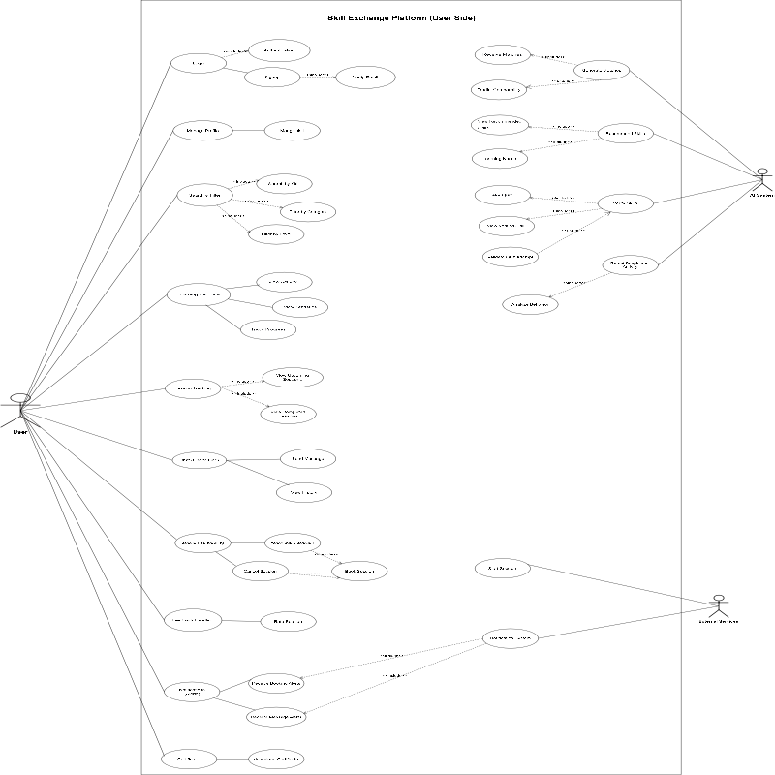

Admin Side
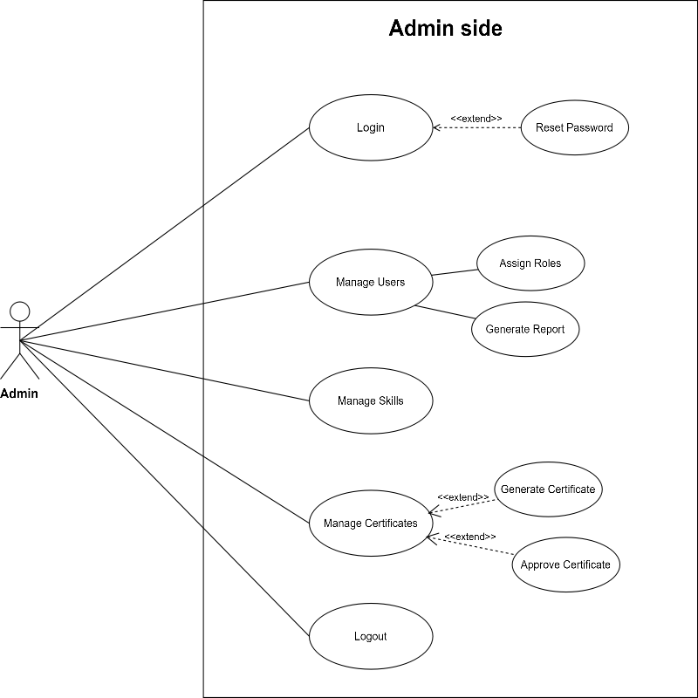

Premium Feature
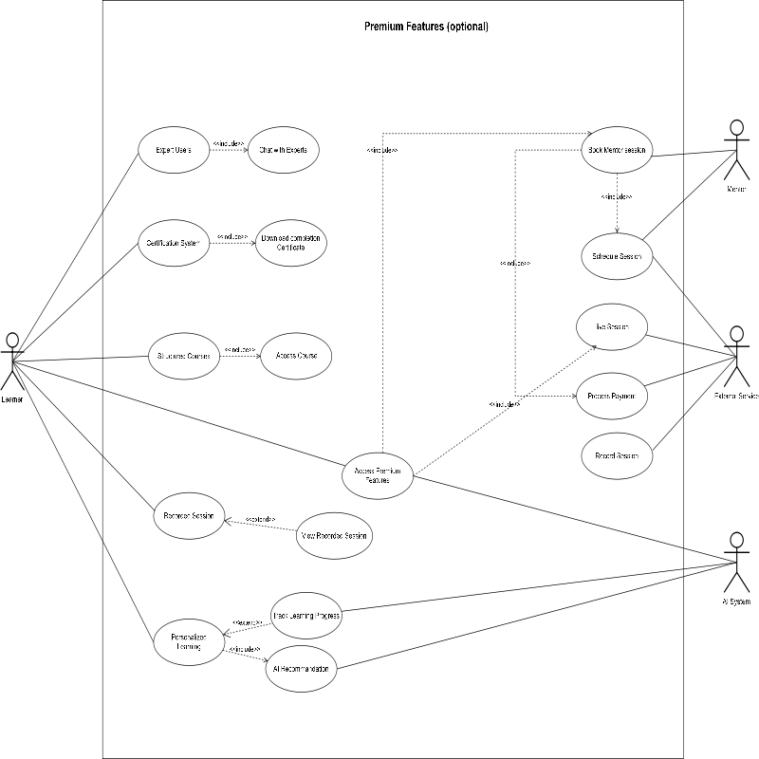

Fully Dressed Use Cases

Use Case 1 : Register User

Field | Description
Use Case Name | Register User
Primary Actor | User
Secondary Actor | Database
Preconditions | User is not already registered.System is available.
Postconditions | User account is created.User data is securely stored in database.
Trigger | User clicks “Register” button.
Main Success Scenario (Basic Flow) | 1. User opens registration page.2. User enters required details.3. System validates input.4. System stores user data in database.5. System confirms successful registration.
Alternate Flows | 4a. Email already exists → system shows error.3a. Invalid input → user re-enters details.

Use Case 2 : User Login

Field | Description
Use Case Name | User Login
Primary Actor | User
Secondary Actor | Database
Preconditions | User account exists.User is registered in system.
Postconditions | User is logged into system successfully.
Trigger | User clicks “Login” button.
Main Success Scenario (Basic Flow) | 1. User opens login page.2. User enters email and password.3. System validates credentials.4. System grants access.5. Dashboard is displayed.
Alternate Flows | 3a. Invalid credentials → system shows error.3b. Account blocked → login denied.

Use Case 3 : Manage Skills
Field | Description
Use Case Name | Manage Skills
Primary Actor | User
Secondary Actor | Database
Preconditions | User is logged in.
Postconditions | Skills are updated successfully.
Trigger | User selects “Manage Skills” option.
Main Success Scenario (Basic Flow) | 1. User opens profile section.2. User adds or edits skills.3. System validates entered information.4. System updates skill data.5. Confirmation message is displayed.
Alternate Flows | 3a. Invalid skill data → system requests correction.

Use Case 4 : Search and Filter Skills
Field | Description
Use Case Name | Search and Filter Skills
Primary Actor | User
Secondary Actor | Database
Preconditions | User is logged into system.
Postconditions | Matching skills/users are displayed.
Trigger | User enters search keyword.
Main Success Scenario (Basic Flow) | 1. User opens search page.2. User enters skill keyword.3. User applies filters.4. System searches database.5. Results are displayed.
Alternate Flows | 5a. No results found → system displays notification.

Use Case 5 : AI Match Recommendation
Field | Description
Use Case Name | AI Match Recommendation
Primary Actor | AI System
Secondary Actor | Database
Preconditions | User profile and skills are available.
Postconditions | Recommended matches are displayed.
Trigger | User opens recommendation section.
Main Success Scenario (Basic Flow) | 1. System analyzes user profile.2. System checks learning needs.3. AI predicts compatibility.4. System generates recommendations.5. User views suggested matches.
Alternate Flows | 4a. No compatible user found → related skills are suggested.

Use Case 6 : Session Scheduling
Field | Description
Use Case Name | Session Scheduling
Primary Actor | User
Secondary Actor | Database
Preconditions | User is logged in.Matching partner exists.
Postconditions | Session is booked successfully.
Trigger | User clicks “Schedule Session”.
Main Success Scenario (Basic Flow) | 1. User selects learning partner.2. User chooses date and time.3. System checks availability.4. User confirms booking.5. System stores session details.6. Notifications are sent.
Alternate Flows | 3a. Time slot unavailable → user selects another slot.

Use Case 7 : One-to-One Chat
Field | Description
Use Case Name | One-to-One Chat
Primary Actor | User
Secondary Actor | Database
Preconditions | Both users are logged in.
Postconditions | Messages are saved successfully.
Trigger | User opens chat window.
Main Success Scenario (Basic Flow) | 1. User selects another user.2. User types message.3. System sends message.4. Receiver gets notification.5. Chat history is stored.
Alternate Flows | 3a. Receiver offline → message delivered later.

Use Case 8 : Feedback and Rating
Field | Description
Use Case Name | Feedback and Rating
Primary Actor | User
Secondary Actor | Database
Preconditions | Learning session is completed.
Postconditions | Feedback and rating are saved.
Trigger | User selects completed session.
Main Success Scenario (Basic Flow) | 1. User opens feedback section.2. User selects session.3. User gives rating and comments.4. System stores feedback.5. Updated ratings are displayed.
Alternate Flows | 3a. User skips feedback → session closes without rating.

Use Case 9 : Session Tracking
Field | Description
Use Case Name | Session Tracking
Primary Actor | User
Secondary Actor | Database
Preconditions | User is logged in.
Postconditions | User progress is updated and displayed.
Trigger | User opens dashboard.
Main Success Scenario (Basic Flow) | 1. User opens dashboard.2. System displays sessions.3. System tracks learning progress.4. User views statistics and reports.
Alternate Flows | 2a. No sessions available → empty dashboard message displayed.

Use Case 10 : Download Certificate
Field | Description
Use Case Name | Download Certificate
Primary Actor | User
Secondary Actor | Database
Preconditions | User completed required sessions.
Postconditions | Certificate is downloaded successfully.
Trigger | User clicks “Download Certificate”.
Main Success Scenario (Basic Flow) | 1. User opens certificate section.2. System checks eligibility.3. System generates certificate.4. User downloads certificate.
Alternat Flows | 2a. Requirements incomplete → download option disabled.

Chapter 4

System Design

Chapter 4: System Design
This chapter focuses on the overall design of the AI-Based Skill Barter Platform, explaining how different system components work together to provide efficient skill exchange and learning services. It describes the architectural design, system models, and the structure of both frontend and backend modules. The chapter also explains the database design, deployment structure, and integration of AI-based recommendation features within the platform. Special attention is given to building a scalable, secure, user-friendly, and maintainable system that fulfills both functional and non-functional requirements. Furthermore, this chapter illustrates the workflows, communication process, data flow, and interaction between modules such as user management, skill matching, session scheduling, chat system, feedback handling, and progress tracking to ensure system reliability, performance, and future enhancement capabilities.

Architecture Diagram
The system follows a Hybrid 3-Tier Layered Client-Server Architecture, where the presentation layer communicates with backend services through a centralized application layer, while data is managed in a dedicated database layer. Specialized services such as AI processing and authentication are integrated within the application tier.
Reason for Using Hybrid 3-Tier Layered Client-Server Architecture
This architecture was chosen because it keeps the system organized by separating the user interface, application logic, and database into different layers. It makes the platform easier to develop, maintain, and upgrade. It also improves security, performance, and scalability. The hybrid approach allows additional services such as AI recommendations and authentication to be integrated efficiently, making the system more flexible and suitable for future growth.

High level Architecture
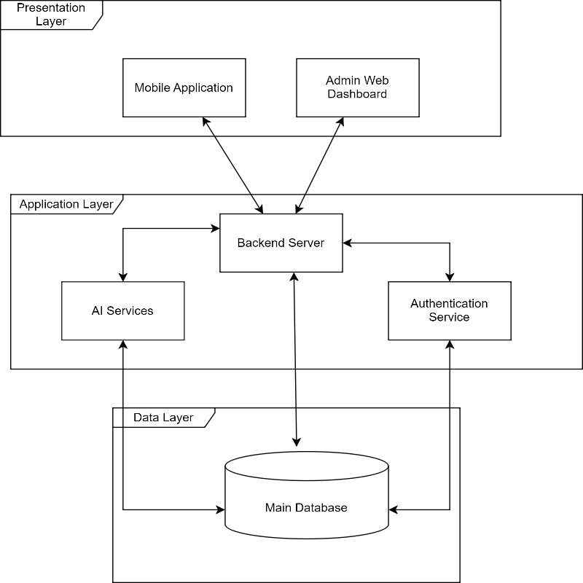

Low level Architecture
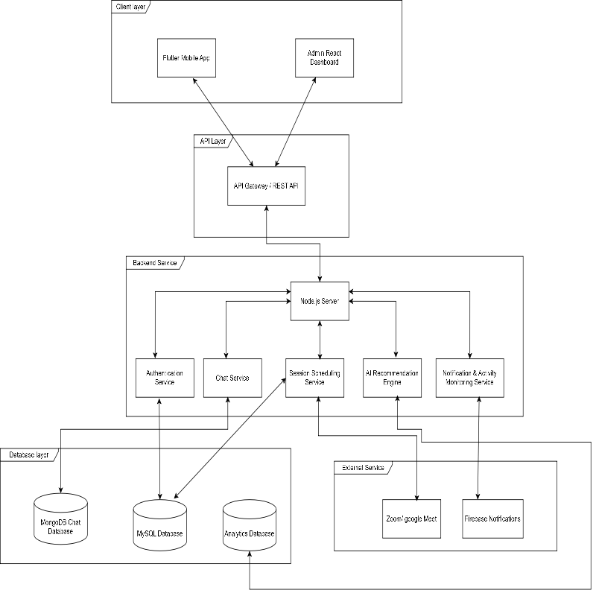

Domain Model
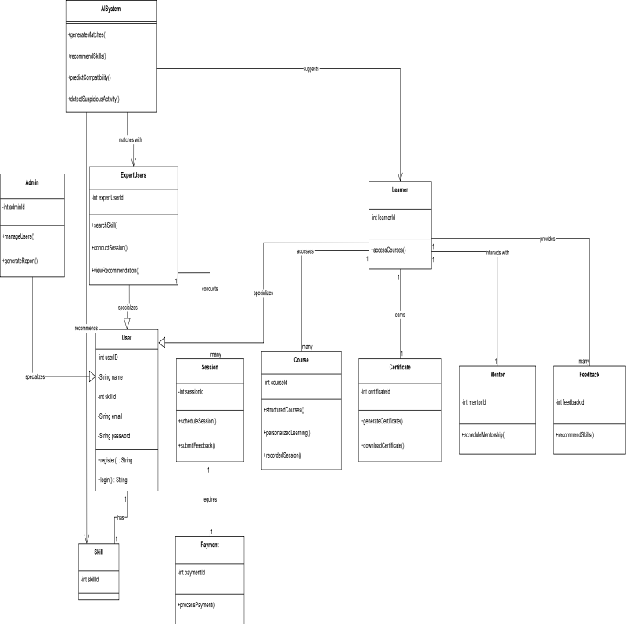

Entity Relationship Diagram with data dictionary
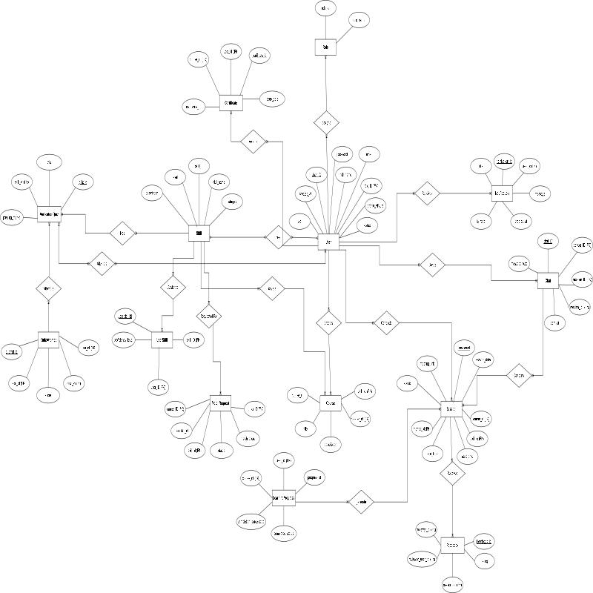

Class Diagram
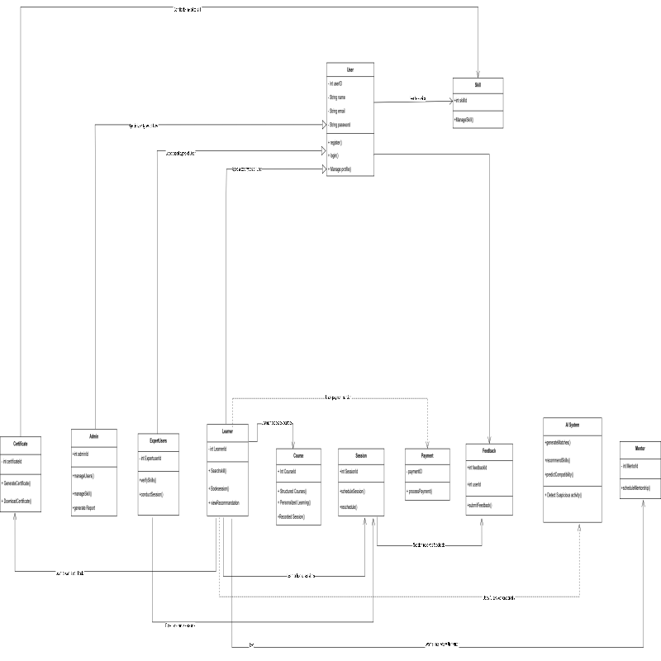

Sequence / Collaboration Diagram
User Side

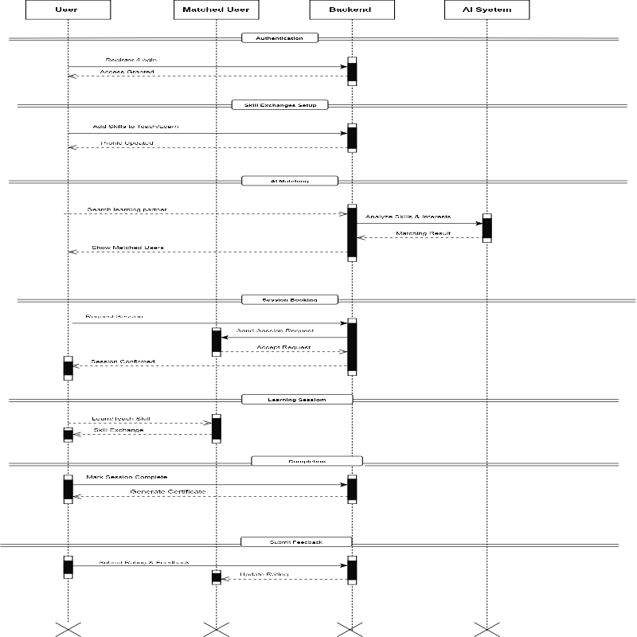

Admin Side
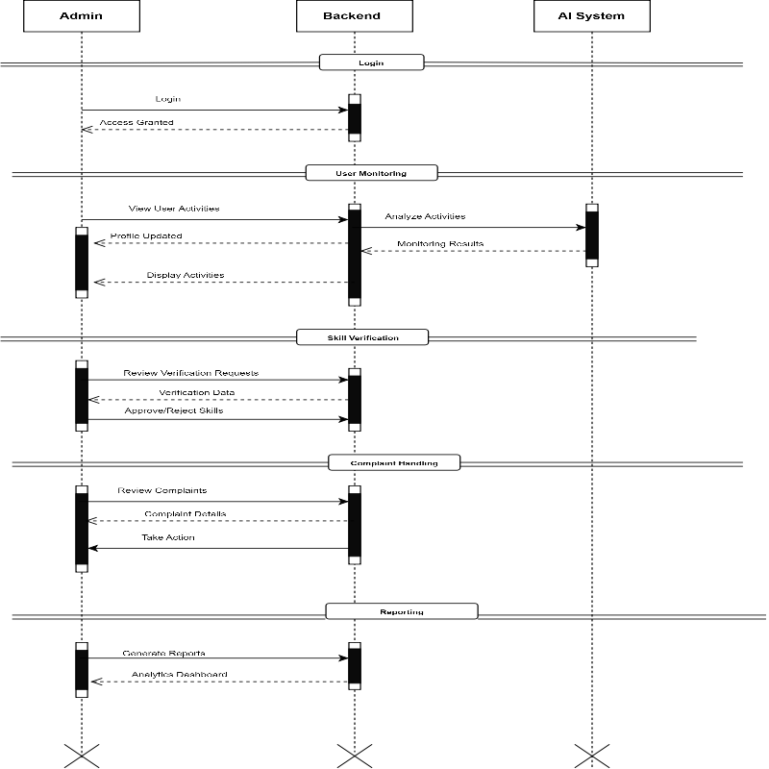

Premium feature
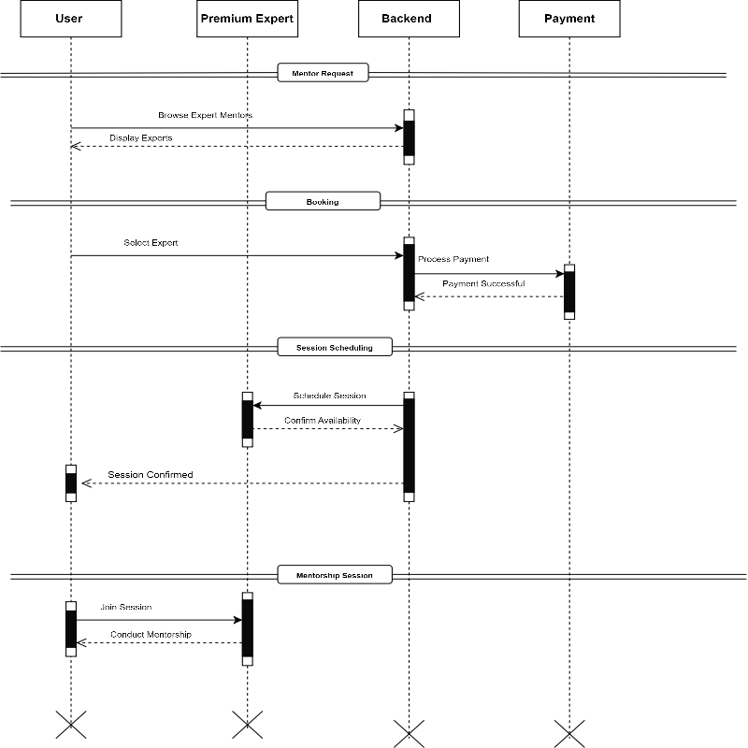

Activity Diagram
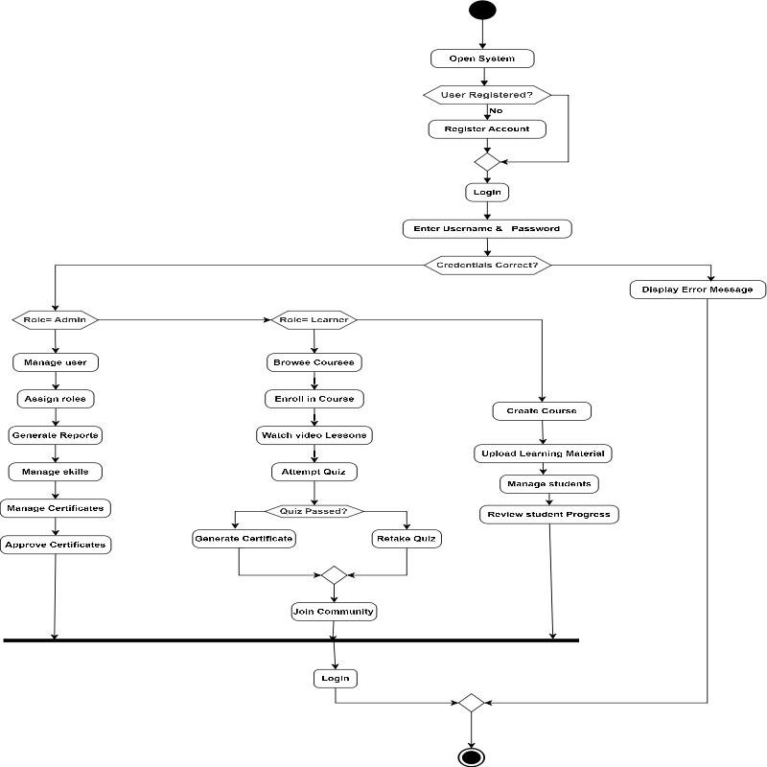

State Transition Diagram
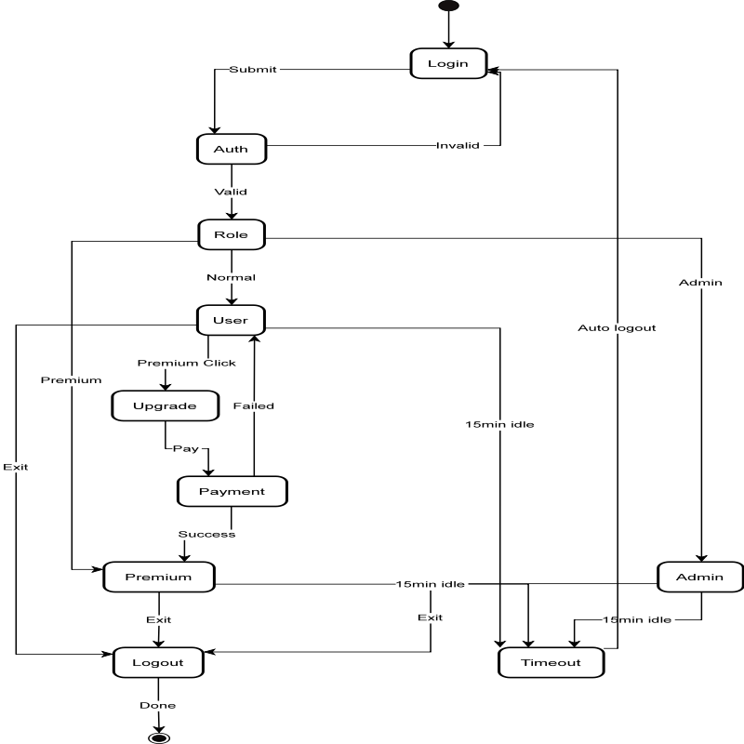

Deployment Diagram
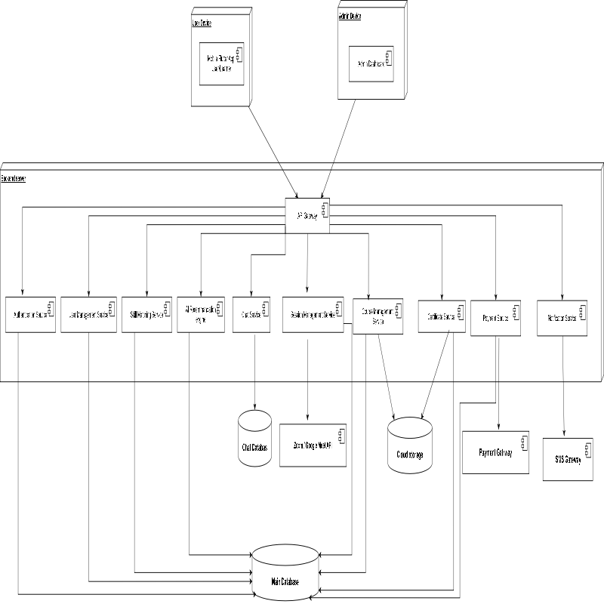

Data Flow diagram [only if structured approach is used - Level 0 and 1]
Level 0
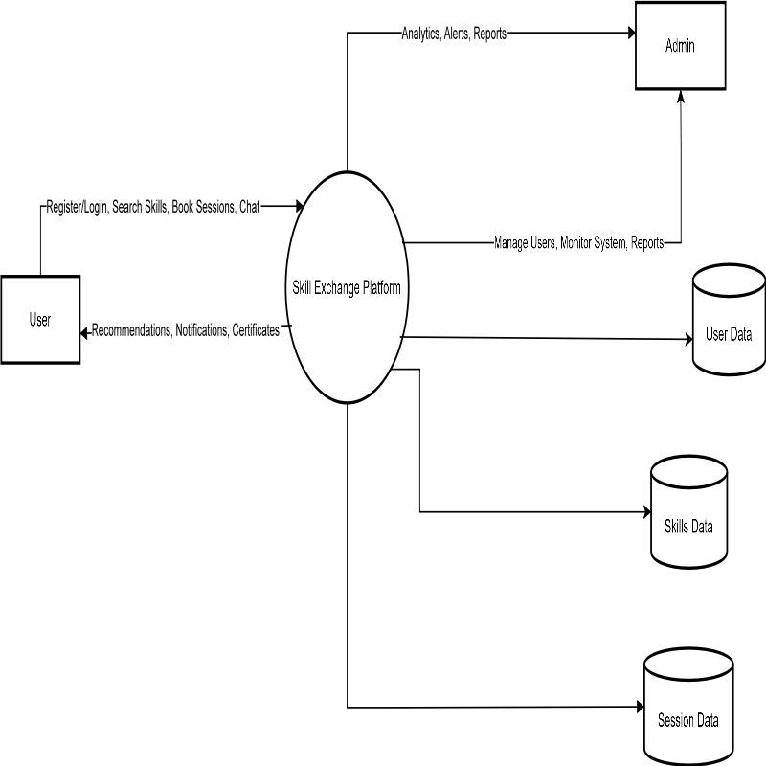

Level 1

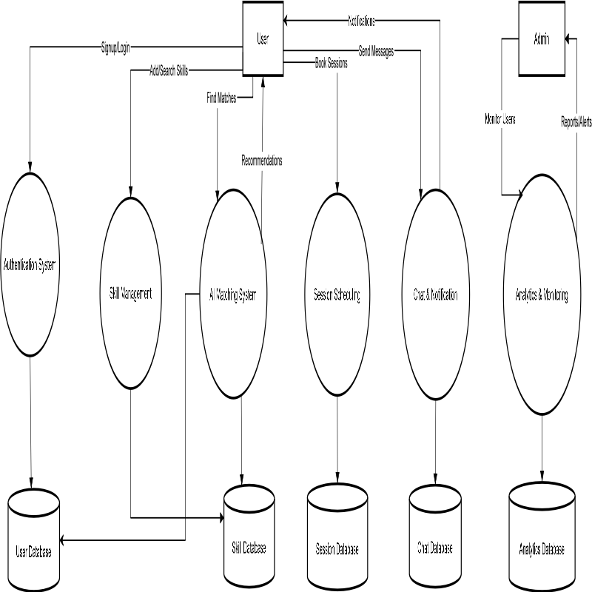

Chapter 5

Implementation

Chapter 5: Implementation
This chapter describes the implementation of the Skill Exchange Platform. It explains the technologies, tools, frameworks, and development approaches used to build the system. The implementation phase transformed the system design and requirements into a functional application that enables users to exchange skills, communicate, schedule sessions, and participate in a secure learning environment.

Important Flow Control/Pseudo codes
This section describes the logical flow and algorithms used to implement the major functionalities of the Skill Exchange Platform.

5.1.1 User Registration & Authentication

Pseudo Code
START
User enters registration details
IF all required fields are valid THEN
Create user account
Store user information in database
Send verification email
Display success message
ELSE
Display error message
END IF
STOP

Flow Description
The user provides personal information during registration. The system validates the input, creates an account, stores the information in the database, and grants access after successful authentication.

5.1.2 AI-Based Skill Matching

Pseudo Code
START
Get user learning skills
Get available teacher skills
FOR each teacher
Compare teacher skills with learner requirements
Calculate matching score
END FOR
Sort teachers by matching score
Display top matching users
STOP

Flow Description
The system compares the learner's desired skills with available teacher skills and generates recommendations based on matching criteria.

5.1.3 Skill Verification Process

Pseudo Code
START
User submits verification request
IF quiz selected THEN
Conduct skill assessment quiz
Calculate score
IF score >= passing criteria THEN
Mark skill as verified
ELSE
Reject verification
END IF
ELSE
Receive supporting documents
Send documents for review
Update verification status
END IF
STOP

Flow Description
Users must verify their skills through quizzes or document submission before they can teach on the platform.

5.1.4 Session Scheduling

Pseudo Code
START
Learner selects teacher
Choose preferred date and time
IF teacher is available THEN
Create session
Send confirmation to both users
ELSE
Request another time slot
END IF
STOP

Flow Description
The scheduling module checks availability and creates learning sessions only when both users agree on the selected schedule.

5.1.5 Chat & Messaging

Pseudo Code
START
User sends message
Store message in database
Send notification to receiver
Display message in chat window
STOP

Flow Description
Messages are stored in real time and delivered instantly to facilitate communication between learners and teachers.

5.1.6 Rating & Feedback System

Pseudo Code
START
Session completed
Request feedback from users
User submits rating and review
Store feedback in database
Update user reputation score
STOP

Flow Description
After every completed session, users provide ratings and reviews that contribute to the reputation and credibility of platform members.

5.1.7 AI-Powered Admin Monitoring

Pseudo Code
START
Monitor user activities
FOR each activity
Analyze behavior patterns
IF suspicious activity detected THEN
Generate alert
Notify admin
END IF
END FOR
Generate system reports
STOP

Flow Description
The AI-powered admin module continuously monitors platform activities, identifies suspicious behavior, and assists administrators in maintaining platform quality and security.

Components, Libraries, Web Services and stubs
This section describes the software components, development libraries, external web services, and stubs used in the implementation of the Skill Exchange Platform.

5.2.1 Components
The system is divided into multiple functional components to ensure modularity, maintainability, and scalability.

User Authentication Component
- User Registration
- User Login
- Password Recovery
- Session Management

User Profile Component
- Profile Creation
- Profile Editing
- Skill Management
- Verification Status Management

AI Matching Component
- Skill Matching
- Recommendation Generation
- User Pairing

Communication Component
- Real-Time Chat
- Notifications
- Message History

Session Management Component
- Session Scheduling
- Session Updates
- Session Reminders

Admin Component
- User Monitoring
- Complaint Management
- Verification Management
- Analytics Dashboard

5.2.2 Libraries
Several libraries were used to simplify development and improve system functionality.
Library | Purpose
Flutter Material Package | User Interface Development
Firebase Auth | User Authentication
Cloud Firestore | Database Management
Provider / Riverpod | State Management
HTTP Package | API Communication
Flutter Local Notifications | Notifications and Alerts
Google Fonts | User Interface Styling
Image Picker | Profile Image Upload
These libraries helped reduce development time and improve application performance.

5.2.3 Web Services
The platform integrates external web services to provide additional functionality.

Firebase Authentication Service
Used for:
- User Registration
- User Login
- Password Reset
- Secure Authentication

Firebase Firestore Service
Used for:
- User Data Storage
- Chat Data Management
- Session Information
- Ratings and Feedback

Google Meet API
Used for:
- Online Learning Sessions
- Meeting Link Generation
- Virtual Classroom Integration

AI Services
Used for:
- Skill Matching
- User Verification Assistance
- Activity Monitoring
- Recommendation Generation

5.2.4 Stubs
During development and testing, stubs were used to simulate components that were not fully implemented.

AI Matching Stub
A temporary matching module was used to generate sample matching results before the final AI algorithm was integrated.

Notification Stub
Dummy notifications were generated during testing before connecting the actual notification service.

Meeting Service Stub
Mock meeting links were used during development before integrating Google Meet functionality.

Payment Stub (Future Premium Feature)
A simulated payment process was created for testing premium course functionality before integrating a real payment gateway.

Deployment Environment
The deployment environment defines the hardware, software, network infrastructure, and cloud services used to deploy and run the Skill Exchange Platform. The system is designed to provide high availability, scalability, security, and reliable performance for users and administrators.

5.3.1 Client Environment
The client environment consists of the devices used by learners, teachers, and administrators to access the platform.

Supported Devices
- Android Smartphones
- iOS Smartphones
- Tablets
- Desktop and Laptop Computers (Admin Panel)

Client Requirements
- Stable Internet Connection
- Modern Web Browser (for Admin Panel)
- Android or iOS Operating System
- Minimum 2 GB RAM recommended

5.3.2 Server Environment
The backend services are deployed on cloud infrastructure to ensure scalability and reliability.

Server Specifications
- Cloud-Based Hosting Platform
- Node.js Runtime Environment
- REST API Services
- Secure HTTPS Communication

Server Responsibilities
- Processing User Requests
- Authentication and Authorization
- AI-Based Skill Matching
- Session Management
- Notification Handling
- Data Processing and Storage

5.3.3 Database Environment
The platform uses a cloud-based database to store and manage application data.

Database Technology
- Firebase Firestore

Stored Information
- User Profiles
- Skills and Learning Interests
- Verification Records
- Chat Messages
- Session Information
- Ratings and Feedback
- Admin Logs and Reports

Database Features
- Real-Time Synchronization
- Automatic Backup Support
- Secure Data Storage
- High Availability

5.3.4 Network Environment
The system requires a reliable network infrastructure to support communication and real-time services.

Network Requirements
- Internet Connectivity
- Secure HTTPS Protocol
- API Communication between Client and Server
- Real-Time Data Synchronization

Supported Services
- Real-Time Chat
- Session Scheduling
- Notifications
- Online Learning Sessions

5.3.5 Third-Party Services
The platform integrates several external services to enhance functionality.

Firebase Services
- Authentication
- Firestore Database
- Cloud Storage

Google Meet API
- Online Session Creation
- Meeting Link Generation
- Virtual Learning Sessions

AI Services
- Skill Matching
- User Verification Support
- Activity Monitoring
- Recommendation Generation

5.3.6 Deployment Architecture
The Skill Exchange Platform follows a cloud-based 3 tier architecture.
Flow of Deployment:
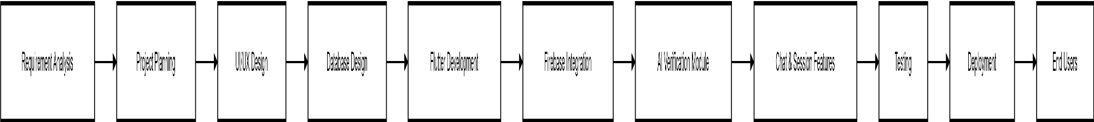

This architecture ensures efficient communication between users, backend services, AI modules, and third-party integrations while maintaining scalability and security.

Tools and Techniques
This section describes the tools, technologies, and development techniques used during the implementation of the Skill Exchange Platform. These tools helped in designing, developing, testing, and deploying the system efficiently.

5.4.1 Development Tools
Various software development tools were used throughout the project lifecycle.

Visual Studio Code (VS Code)
Visual Studio Code was used as the primary Integrated Development Environment (IDE) for writing, debugging, and managing the source code of the application.

GitHub
GitHub was used for version control and source code management. It helped track changes, maintain backups, and support collaborative development.

Postman
Postman was used for testing APIs and verifying communication between the frontend and backend services.

Firebase Console
Firebase Console was used to manage authentication services, cloud database operations, and application configurations.

5.4.2 Development Techniques
The following software development techniques were applied during implementation:

Modular Development
The system was divided into independent modules such as authentication, profile management, skill matching, chat, scheduling, and administration. This improved maintainability and scalability.

Client-Server Architecture
The application follows a client-server architecture where the Flutter frontend communicates with backend services and cloud databases through APIs.

Agile Development Approach
Development was carried out incrementally, allowing features to be implemented, tested, and improved continuously throughout the project.

Component-Based Development
Reusable components were developed to reduce code duplication and simplify future enhancements.

5.4.3 Testing Tools and Techniques
Testing was performed throughout development to ensure system quality and reliability.

Unit Testing
Individual modules and functions were tested independently to verify correct functionality.

Integration Testing
Testing was performed to ensure smooth communication between different system modules.

System Testing
The complete application was tested as a whole to verify that all requirements were satisfied.

User Interface Testing
UI testing was conducted to ensure that screens, forms, and navigation worked correctly across supported devices.

5.4.4 Database Techniques
The following techniques were used for managing and storing data:
- Cloud-based database management using Firebase Firestore
- Real-time data synchronization
- Secure user data storage
- Data validation before database operations
- Backup and recovery support

5.4.5 AI Techniques
Artificial Intelligence techniques were incorporated to enhance platform functionality.

Skill Matching Algorithm
AI-based matching was used to recommend suitable learning partners based on skills, interests, and learning goals.

Skill Verification Assistance
AI-assisted verification helped evaluate quizzes and review user-submitted information.

Activity Monitoring
AI techniques were used to identify suspicious activities and support administrative decision-making.

5.4.6 Communication Techniques
To support collaboration and interaction among users, the following techniques were implemented:
- Real-time messaging
- Push notifications
- Online session scheduling
- Video meeting integration through Google Meet

Best Practices / Coding Standards
This section describes the coding standards and software development best practices followed during the implementation of the Skill Exchange Platform. These practices improve code quality, maintainability, readability, security, and overall system performance.

5.5.1 Coding Standards
The development team followed standardized coding conventions to ensure consistency throughout the project.

Meaningful Naming Conventions
- Variables, functions, classes, and files were given meaningful and descriptive names.
- Naming conventions were kept consistent across all modules.
Example:
getUserProfile()
scheduleSession()
verifySkill()

Code Formatting
- Proper indentation and spacing were maintained.
- Consistent code structure was followed throughout the project.
- Unnecessary code complexity was avoided.

Commenting and Documentation
- Important functions and modules were documented using comments.
- Complex logic was explained for easier understanding and maintenance.

5.5.2 Modular Programming
The application was developed using a modular approach.

Practices Followed
- Authentication module separated from profile management.
- Chat functionality implemented independently.
- AI matching and verification modules developed separately.
- Admin functionalities organized into dedicated modules.

Benefits
- Easier maintenance
- Better scalability
- Improved code reusability
- Simplified debugging

5.5.3 Security Best Practices
Security was considered throughout the development process.

Practices Followed
- Secure user authentication mechanisms
- Encrypted password storage
- Role-based access control
- Secure API communication using HTTPS
- Input validation and sanitization

Benefits
- Protection against unauthorized access
- Reduced security vulnerabilities
- Improved user trust

5.5.4 Database Best Practices
Proper database management practices were followed to ensure data integrity and performance.

Practices Followed
- Structured database collections
- Data validation before storage
- Avoidance of duplicate data
- Efficient query design
- Regular backup procedures

Benefits
- Faster data retrieval
- Improved database performance
- Better data consistency

5.5.5 Version Control Practices
GitHub was used to manage project versions and collaboration.

Practices Followed
- Regular code commits
- Meaningful commit messages
- Backup of project source code
- Tracking changes throughout development

Benefits
- Easy recovery of previous versions
- Improved team collaboration
- Better project management

5.5.6 Testing Best Practices
Testing was performed continuously during development.

Practices Followed
- Unit testing for individual modules
- Integration testing between components
- User interface testing
- Error and exception handling validation

Benefits
- Early bug detection
- Improved system reliability
- Better software quality

5.5.7 User Interface Best Practices
Special attention was given to creating a user-friendly interface.

Practices Followed
- Consistent design across all screens
- Clear navigation structure
- Responsive layouts
- Easy-to-read text and controls

Benefits
- Improved user experience
- Increased usability
- Reduced learning curve

Version Control
Version control was used throughout the development of the Skill Exchange Platform to manage source code, track changes, and support collaborative development. It helped maintain code integrity, prevent data loss, and ensure smooth coordination between team members.

5.6.1 Version Control Tool

Git
Git was used as the primary version control system for tracking modifications made to the project source code.

GitHub
GitHub served as the remote repository for storing, managing, and backing up project files. It also facilitated collaboration between team members by allowing code sharing and version tracking.

5.6.2 Version Control Process
The development team followed a structured version control process throughout the project lifecycle.

Code Development
- Developers implemented new features and fixes in their local development environment.
- Changes were tested before being committed.

Commit Management
- Code changes were saved regularly using commits.
- Each commit included a meaningful message describing the changes made.
Examples:
Added AI skill matching module
Implemented user authentication
Fixed session scheduling bug
Updated admin dashboard UI

Repository Synchronization
- Local changes were pushed to the GitHub repository.
- Team members pulled the latest updates before starting new development tasks.

5.6.3 Benefits of Version Control
The use of version control provided several advantages:

Code Backup
- Source code was securely stored in a remote repository.
- Reduced risk of data loss due to system failures.

Change Tracking
- All modifications were recorded and could be reviewed at any time.
- Previous versions could be restored when necessary.

Collaboration Support
- Multiple team members could work on the project simultaneously.
- Code integration became more organized and manageable.

Error Recovery
- Bugs introduced in newer versions could be traced and corrected easily.
- Stable versions of the project could be recovered quickly.

5.6.4 Repository Structure
The GitHub repository was organized into separate directories for different system components.

Main Project Structure
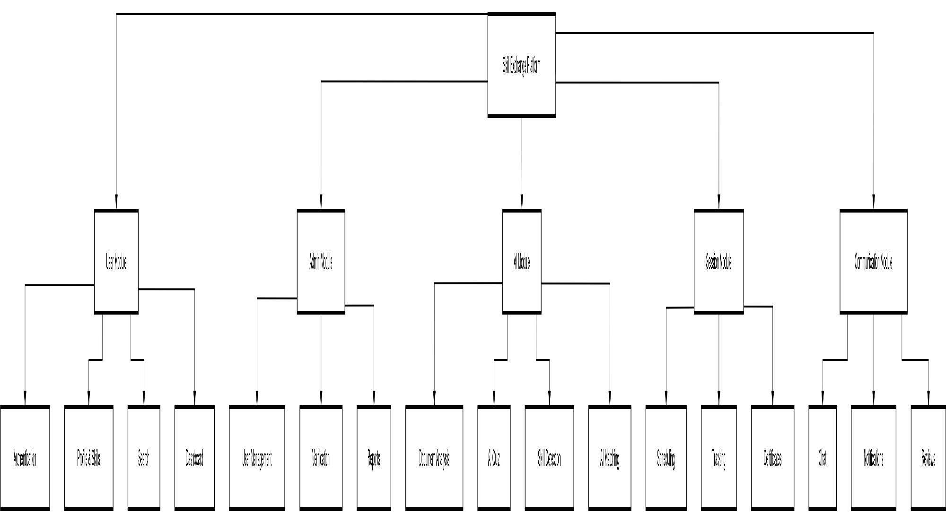

5.6.5 Version Control Best Practices
The following practices were followed during development:
- Frequent commits with meaningful messages
- Regular repository backups
- Consistent project structure
- Proper documentation of code changes
- Synchronization of code before integration
- Maintenance of stable project version

